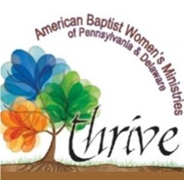
2021 THRIVE GROUP

Recommended List of Books and Studies

- “Revelation - Extravagant Hope” -By Margaret Feinberg NEW!
- “Vibrant” Developing a Deep and Abiding Joy for All Seasons -By Carol McLeod NEW!
- “Walk It Out: The Radical Result of Living God’s Word One Step At A Time” -By Tricia Goyer
- “The Power of a Praying Church” - by Stormie Omartian
- “Uninvited: Living Loved When You Feel LessThan, Left Out and Lonely” - By Lysa Terkeurst
- “The Broken Way: A Daring Path to Abundant Life” - By Ann Voskamp
- “Knowing God By Name” - by Sharon Jaynes, Gwen Smith, Mary Southerland
- “Seeking Him: Experiencing the Joy of Personal Revival” - By Nancy DeMoss, Tim Grissom
- “Lioness Arising: Wake Up and Change Your World” – By Lisa Bevere
- “The Armor of God” – By Priscilla Shirer
- "20/20: Seen. Chosen. Sent. Bible Study Book" - By Christine Caine
Books from previous years remain as recommendations for personal or group use.
Each lady participating can received $5.00 reimbursement with proof of purchase.
For a first-time group, the leader’s guide is paid in full by ABWM.
Thrive Groups are not limited to the books listed above. Approval for other books should be obtained before the books are purchased to receive the $5.00 reimbursement.
Books are available at Amazon, Christian Book Distributors, Lifeway, or your local Christian bookstore.
For questions, help or advice contact:
Jodie Vasbinder, Spiritual Enrichment Coordinator
jesusavesptl@gmail.com 814-845-2355

